Mobile App Reverse Engineering Tutorial Static Analysis of Android APKs using JADX & Radare2
Isabella Sunderman

This tutorial is a continuation of the Mobile App Security Tutorial- 1. This tutorial builds off the tools and techniques applied in the prior tutorial. The required tools for this tutorial include Android Studio and Frida for a dynamic analysis on the Uncrackable 3 APK from OWASP, but the tutorial is primarily static. The tasks performed in the tutorial on other applications without permission is illegal and unethical, and performed on a vetted application made for the tasks conducted.

Java code Analysis with JADX
  - Set up your working environment, you can use the same emulated device created in the prior tutorial and install the new APKs.
Try starting the application or getting a PID using Frida.
Here is the output of the enum3.js script from the repository

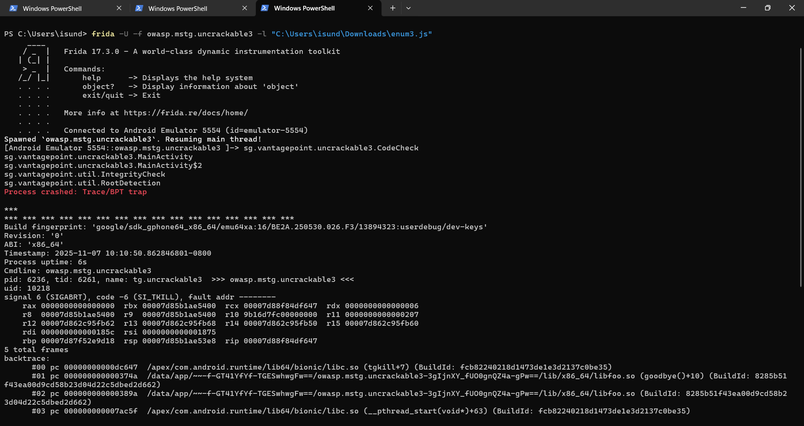

Notice the process terminates meaning the application has security measures in place to prevent execution in root namely the sg.vantagepoint.util.RootDetection. The output also provides some clues as to functions to investigate further. Such as 2 MainActivity returned in the output before the app crashes.

  - JADX
We will need to investigate the code of the application, JADX can decompile the java code from the APK. The tool reads the APK and shows the readable Java code and can be used to locate suspicious functions and strings
To install follow the link to the latest version: https://github.com/skylot/jadx/releases/tag/v1.5.3
Download the folder and run the executable

  - Activity 1: Functions and phrase analysis
Open the Uncrackable 2 file in JADX and search the following phrases:
- System.loadLibrary
- isDebuggerConnected
- System.exit
- Sg.vantagepoint.a.b
- CodeCheck

  - Challenge 1:
Go through each phrase and answer the following questions:
- What does each phrase return?
- Do any of the phrases tell us anything notable to the obtain the phrase?
- What does each line mean to the apps security?

  - Activity 2:
Scanning the MainActivity we can also see an xor key with the string “pizzapizzapizzapizzapizz” there is also a native void (initbyte[]) and native long baz().
Look at the logic for the root and tempering detection done in the MainActivity. Find the native methods declared , we will be look at them in the next section.

Native Code analysis with Radare2
Since there are still some issues that need to be uncovered the JADX and Frida alone can’t do Radare2 is another tool that can be used to uncover the secret passphrase.
2.1 Installing Radare2
The tutorial is made using Windows and windows PowerShell was used for the commands there may be some syntax differences between Linux and Windows.
The following commands can be used for Linux
For Windows you can use scoop to install:
2.2 Activity 3: Application extraction and preliminary:
Once Radare2 is installed we need to extract the APK file for inspection. We will be extracting the files straight from the emulated device to get the exact package.
This will be extracting the application from the emulated device and setting up the file to be analyzed with radare2 in put the following commands with the ADB shell:
In a new terminal:
The output should resemble this: 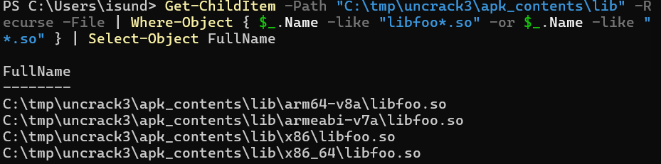
The following commands are using radare2 package rabin2 to obtain some information form the native code about the application functions will need to know that ABI for the device we are using, this tutorial is conducted on a Pixel 5 AVD which is x86_64.
2.3 Challenge 2:
Using the output of the above command you should be able to answer the following questions:
- What are the global functions found in the -s command and do they correspond to a function found in the JADX analysis? What are the mappings
- What are the memory addresses for the Java class functions?
- What function is at address 0x00003740?
2.4 Activity 4:
Useful interactive commands:
aa — analyze all | afl — list functions
iz — list strings | axt <addr> — show cross-references to an address (useful to find who references detector strings)
axt sym.imp.strstr — find calls to strstr import (common pattern for /proc/self/maps scan) | pdf @ <addr> — print function disassembly at address <addr>
pdd @ <addr> — decompile function to pseudo-C (if r2dec available)

Try using the commands to understand the logic of the native code of the application.

2.5 Challenge 3:
1. What Strings were found during the exploration using the ‘iz’ command?
2. Which functions are the JNI exports?
3. what is the address for the strings “Frida” and “xposed”?

Appendix
Challenge 1:
- - System.loadLibrary("foo"): loads native library (libfoo.so). Native code may run checks before Java code.
- Debug.isDebuggerConnected() inside AsyncTask: a loop that waits for debugger attach and then shows "Debugger detected!" dialog.
- if (b.a() || b.b() || b.c()) a("Root detected!"): three root detection functions
- System.exit(0) on OK. if any sg.vantagepoint return true, the app shows a blocking alert which calls
- if (a.a(getApplicationContext())) a("App is debuggable!"): debuggable flag check - shows blocking dialog.
- CodeCheck.a(String): verification routine called from verify(View). This is the function students will target for forced-success or extraction.
Challenge2:
- • Java_sg_vantagepoint_uncrackable3_CodeCheck_bar
Maps to: CodeCheck.bar(...) native method (Java native declaration likely in class sg.vantagepoint.uncrackable3.CodeCheck).
• Java_sg_vantagepoint_uncrackable3_MainActivity_baz
Maps to: MainActivity.baz() native method.
• Java_sg_vantagepoint_uncrackable3_MainActivity_init
Maps to: MainActivity.init(byte[]) native method.
- 0x00003a70 sym.Java_sg_vantagepoint_uncrackable3_CodeCheck_bar 0x00003a60 sym.Java_sg_vantagepoint_uncrackable3_MainActivity_baz
- Sym.goodbye is at 0x00003470
Challenge 3:
- 0 ascii /proc/self/maps
1 frida
2 xposed
3 ascii UnCrackable3
4 Tampering detected! Terminating...
- Error opening /proc/self/maps! Terminating...

- Java_sg_vantagepoint_uncrackable3_CodeCheck_bar
Java_sg_vantagepoint_uncrackable3_MainActivity_baz
Java_sg_vantagepoint_uncrackable3_MainActivity_init

- "frida" — 0x00003b62 (vaddr)
"xposed" — 0x00003b68 (vaddr)

References
https://github.com/skylot/jadx/releases/tag/v1.5.3

